Grid for crossword puzzle over chapt. 9 of Discovering Missions by Gailey and Culbertson
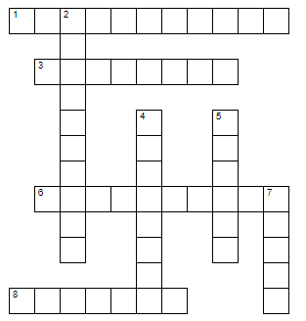

Puzzle clues are at: https://home.snu.edu/~hculbert/miss9.htm

