Grid for crossword puzzle over chapter 6 of Discovering Missions by Gailey and Culbertson
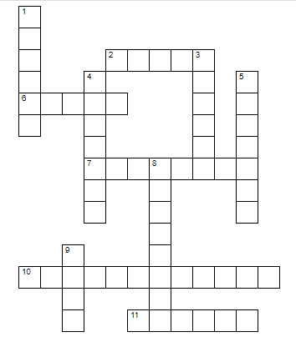
Puzzle clues are at: https://home.snu.edu/~hculbert/miss6.htm

