Grid for crossword puzzle over chapt. 13 of Discovering Missions by Gailey and Culbertson
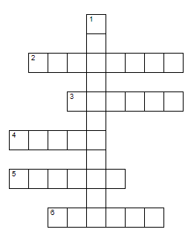
Puzzle clues are at: https://home.snu.edu/~hculbert/miss13.htm

