Grid for crossword puzzle over chapt. 12 of Discovering Missions by Gailey and Culbertson
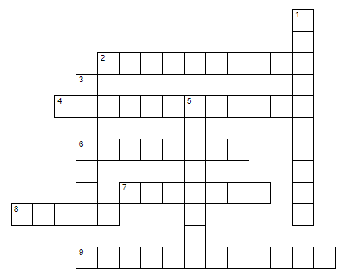
Puzzle clues are at: https://home.snu.edu/~hculbert/miss12.htm

