Grid for crossword puzzle over chapter 11 of Discovering Missions by Gailey and Culbertson
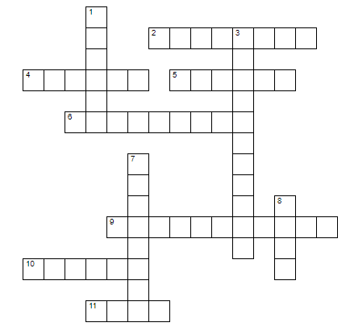
Puzzle clues are at: https://home.snu.edu/~hculbert/miss11.htm

